Rules of Article Forming

1. Basic conditions
The manuscript can be sent to the editorial office of the journal only if the following conditions are met:
• the research was conducted with the highest standards of care and conscientiousness;
• the manuscript is original and has not been published anywhere else, including by the authors of the manuscript;
• the work has not been submitted anywhere else and is not reviewed with any other publication;
• work does not contain defamatory, discreditable or illegal statements;
• allowed to use any third-party materials;
• confirmation of consent has been obtained from all specified persons or organizations;
• authorship was agreed prior to submission, and no one was “gifted” with authorship or refused to be credited as an author (ghostly authorship).

If your research is published and we find that any of these conditions have not been met, we may take action in accordance with COPE guidelines, which may result in one of the correction notices, or we may remove or revoke the article.

Additions and additional materials
Electronic additional materials for the article (Excel files, audio and video files) can be published at the request of the authors.

2. Requirements for the text
Font – Times New Roman
Font size – 14
Interval – 1
Margins of the document – 20 mm
Minimum number of pages – 15
Article language: Ukrainian, English (only for foreigners)
3. Structure of article

UDC

TITLE OF THE ARTICLE IN UKRAINIAN

First Name Last Name, First Name Last Name…. in Ukrainian
TITLE OF THE ARTICLE IN ENGLISH

First Name Last Name, First Name Last Name…. in English

Abstract in Ukrainian
Keywords in Ukrainian

Abstract in English
Keywords in English

1. Introduction
2. Literature review and problem statement
3. The aim and objectives of the study
4. Materials and methods
5. Results
6. Discussion of results
7. Conclusion

Conflict of interest
It is necessary to indicate the absence or presence of a conflict of interest. If there is a conflict of interest, it must be specified. When there is no conflict of interest, it is necessary to specify the phrase:

The authors declare that they have no conflict of interest in relation to this research, whether financial, personal, authorship or otherwise, that could affect the research and its results presented in this paper.

Financing
Sources of funding must be indicated. If there is no funding, it is necessary to indicate:

The study was performed without financial support.

Data availability
Choose one of the options and indicate it in the text of the manuscript:
- Manuscript has associated data in a data repository.
- Manuscript has data included as electronic supplementary material.
- Data will be made available on reasonable request.
- Data cannot be made available for reasons disclosed in the data availability statement.
- Manuscript has no associated data.

Use of artificial intelligence
Choose one of the options and indicate it in the text of the manuscript:
- The authors confirm that they did not use artificial intelligence technologies when creating the current work.
- The authors have used artificial intelligence technologies within acceptable limits to provide their own verified data, which is described in the research methodology section.
Images, photorealistic images, diagrams, drawings, figures that have been generated by artificial intelligence should be labeled "Imagined with AI".

Acknowledgments

References

References

Information about authors in English
Information about authors in Ukrainian

4. Requirements for the article title
– It does not contain abbreviations.
– Strictly correspond to the content of article.

5. Requirements for abstracts
– Not less than 1800 characters with spaces, including keywords.
– No more than 1900 characters with spaces, including keywords.
– It does not contain abbreviations that are understandable only from the context of article.

6. Requirements for keywords
– No more than 10 words.
– Do not contain abbreviations that are understandable only from the context of article.
– Separated by commas.

7. Requirements for graphical abstract
A graphical abstract is an image that appears alongside the text abstract in the contents. This is a single, concise, pictorial and visual summary of the main findings of the article.
A graphical abstract should allow readers to quickly gain an understanding of the take-home message of the paper and is intended to encourage browsing, promote interdisciplinary scholarship, and help readers identify more quickly which papers are most relevant to their research interests.

Authors must provide an image that clearly represents the work described in the paper. It could either be the superposition of several figures from the article or a figure that is specially designed for the purpose. Any postage stamps, currency from any country, or trademarked items should not be included in it. Graphical abstracts should be submitted as a separate file.

Requirements for graphical abstract:
– Image size: the minimum required size for the graphical abstract is 560 × 1100 pixels (height × width) with minimum resolution of 300 dpi. If you are submitting a larger image, please use the same ratio. Please note that your image will be scaled proportionally to fit in the available window.
– Font: please use font with a large enough font size as the image will be reduced in size for the table of contents to fit a window.
– File type: .jpg, .jpeg, .png.
– File size: no more than 5 Mb.

No additional text, outline or synopsis should be included. Any text or label must be part of the image file. Please do not use unnecessary white space or a heading “graphical abstract” within the image file.

8. Requirements for formatting figures
- In order to make figures in good quality, you can use our video lessons at the link (a strong request – do not use Microsoft Paint to create or edit your figures. This editor gives a maximum resolution of 120 dpi, which does not meet the requirements of our magazine).
- Before a figure, there must be a reference to the it in the form of Fig. 1, Fig. 2–4, Fig. 5, a. The reference to the figure must be in the same section/subsection as the figure itself.
- The caption under a figure should take the form: Fig. 1. The title of the figure.
If the figure consists of several subfigures, the caption should take the form: Fig. 1. The title of the figure: a ‒ the name of the first subfigure; b ‒ the name of the second subfigure...
- If there are designations or abbreviations in the figure, the transcript of which were not given earlier in the text, then those should be explained in the text under the figure. For example, the figure shows three charts, which are marked, respectively, by numbers 1, 2, and 3. Then the text under the figure should take the form: Fig. 1. Title: 1 ‒ chart 1; b ‒ chart 2; 3 ‒ chart 3.
- Caption under the figure must be part of the text.
- Figures should be streamlined "In text".
- The inscriptions in the figure should not be bold or italic.
- All inscriptions in the figure must be written in one font and one size. The exception is screenshots of programs that do not allow one to edit the font.
- The indices in the figure should take the same form as the indices in the text.
- On the charts, the axes' titles must be moved from the scales to the same distance of at least 0.5 cm.
- At least one size (height or width) of the subfigures should be the same. The horizontally located subfigures should have the same height, and the vertically located ones should have the same width.

- Figures must be of good quality (at least 300 dpi). The inscriptions on the figures should be clear and readable, the lines of the figure should not be blurred. There should be no noise in the figure.

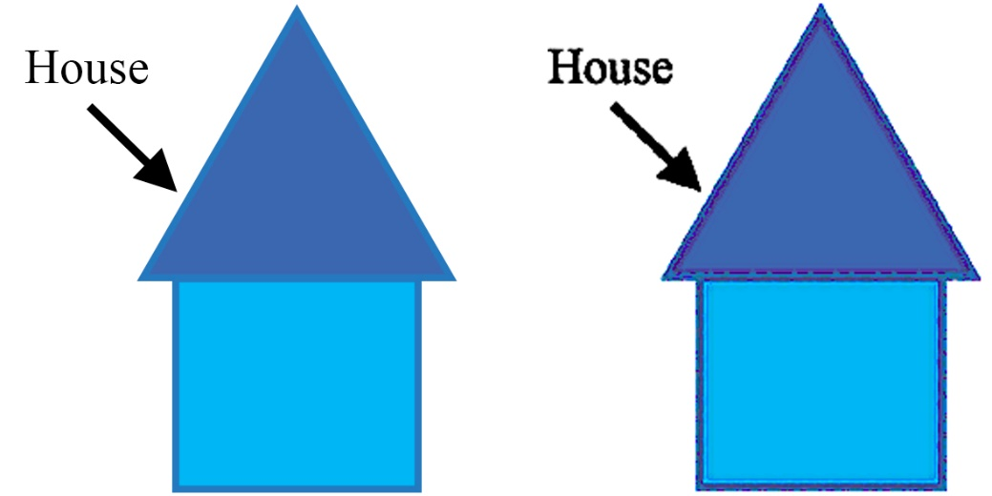

- The editorial board reserves the right to reject a paper if the authors refuse to provide the original figure files to avoid data falsification (dwg ‒ for CAD-system drawings (COMPAS, SolidWorks, AutoCad), cdr ‒ for CorelDRAW files; xls/xlsx ‒ for Excel, etc.).

9. Requirements for formatting of the tables
– The table header does not contain blank cells.
– If the table in your document is divided into several pages, you do not need to re-sign the header on a new page.
– All tables should be vertical.

10. Requirements for formatting of the formulas
– Formulas should be typed in the MathType equation editor.
– Links to the formula in the text should look like (1), (2)–(4).
– Formulas should be numbered.
– Numbering alignment to the right.
– The formula is part of the text, so after a formula must stand semantic mark: if the new proposal goes further, then the dot, if further clarification is the comma.

11. Requirements for formatting of references to literature in the text
– References should take the form [1], [2–6].
– References should be in the order of their mention in the article.
– All literature references cited in the Literature part, reference should be in the text necessarily!

12. Requirements for formatting the list of sources in the literature
– Sources are made according to the standard.
– See how to link to a source located on the OJS platform (link).
– Sources must be at least 10.
– The list of references should have at least 60 % foreign sources.
– If GOSTs and national standards are used in the references, their foreign analogues must be given.
– The percentage ratio of self-citations is no more than 30 % (ie, if you used 10 references, no more than 3 of them can be to your works).
– All sources must be unique (one source is mentioned only once in the bibliography).
– All sources must be provided in the original language (i.e. if an article/book, etc. was published in Ukrainian, sources should also be added to the list of references in Ukrainian, and not a translator or transliteration should be used).
– Before submitting the manuscript to the editor, it is necessary to check all URL sources for operability.
– Sources belonging to the Q1 and Q2 Scopus quartiles should be highlighted in purple. To check the log for belonging to a quartile, you can use this video.

13. Requirements for the list of literature in English (References)
– References in a language articles, translated into English.
– References must be completed according to the standard.

14. Requirements for registration information about the authors
Please provide information about each author according to the example below (in a clear sequence):
English | Ukranian (for Ukraine citizens only)
Full name  Science degree  Department  University  Address University  E-mail:  ORCID:  Contact phone:  Number of publications in national journals indexed (approximate; for Ukraine citizens only)  Number of publications in international journals indexed (approximate)  H-index by Scopus (if available)  ResearchGate:  ID Scopus:  Researcher ID: | Full name  Science degree  Department  University  Address University  E-mail:  ORCID:  Contact phone:  Number of publications in national journals indexed (approximate; for Ukraine citizens only)  Number of publications in international journals indexed (approximate)  H-index by Scopus (if available)  ResearchGate:  ID Scopus:  Researcher ID:

The author's ORCID ID is required. ORCID provides a unique and persistent digital identifier that distinguishes researchers from every other researcher, even those who share the same name, and, through integration in key research workflows such as manuscript and grant submission, supports automated linkages between researchers and their professional activities, ensuring that their work is recognized.

After registration of the articles refer to the checklist (download)

SUBMISSION TO THE EDITOR
Submit a paper to the editors You can of ways
1. Send to e-mail: c7508990@gmail.com or eejet@entc.com.ua.
2. Post an article on-line through the platform OJS (Open journal system) link.
3. Come to the Editor at the address Shatylova dacha str., 4, of. 702, Kharkiv, Ukraine, 61165 (during the period of combat operations, personal reception is not carried out).

EDITING
All manuscripts are first checked by the editor. Only those manuscripts that meet the standards of the journal, and fit within its aims and scope, will be sent to expert reviewers.

Deadline from 2 weeks till 2 months
1. After the article has passed the priority check, it is necessary to provide a package of documents and pay an advance payment after which your article is sent for processing to the editor.
2. Get the answer from the editors of the journal. If there are corrections, it is necessary to take into account all comments and send the revised article back by e-mail to c7508990@gmail.com or eejet@entc.com.ua.

REVIEWING*
Deadline from 1-6 months
1. Our editorial staff is practicing a double-blind peer review.

*Review procedure involves checking for plagiarism, verification of compliance the article title and content, check the content of the article

2. Get the answer from the editors of the journal. If there are corrections, it is necessary to take into account all comments and send the revised article back by e-mail to c7508990@gmail.com or eejet@entc.com.ua.
3. If there are no corrections or all comments made by the reviewers are corrected, the article will be accepted for publication in the journal based on the results of a double-blind peer review.

PACKAGE OF DOCUMENTS FOR THE ARTICLE (Details...)

SPECIAL OFFERS FROM THE EDITOR
The specialists of our editorial can help you with requirements of articles:
– Making Article in accordance with the requirements.
– Professional technical translation of the article into English.
– Making a list of references according to standard.
– Editing pictures.
– Formula design in the MathType formula editor.
– Prepare for publishing your articles to other Ukrainian and foreign scientific publications.

HOW TO GET THE ELECTRONIC VERSION OF THE JOURNAL

– The electronic version of the journal can be seen in the archive on our site (link).

