Dear author! Making an article in our journal according to the requirements that are indicated on the site (link), the Editorial Board raises a number of questions for registration. Please check your article:

1. Have you indicated the UDC to the article?
2. The title of the article corresponds to the content of the article.
3. The name does not contain abbreviations.
4. The number of words in the annotations is 230–250 words.
The number of keywords is no more than 10
(Attention! Number of words, not phrases)
5. The abstract and keywords do not contain abbreviations that are clear only from the context of the article
6. Have you put down all sections of the article? The structure of the article (according to the sample)
1. Introduction
2. Literature review and problem statement
3. The aim and objectives of research
4. Materials and methods of research (the section must be called so that the "experimental" and "methodical" components of the author’s study are understood)
5. Research results (the section must be called so that the essence of the author’s research is understood)
6. Discussion of the results (the section must be called so that the essence of the author’s study is understood)
7. Conclusions
8. Conflict of interest
9. Financing
10. Data availability
11. Use of artificial intelligence
12. Acknowledgments (if any)
Read more about article sections link

7. Have you correctly identified the links in the text to your list of references? We remind you that references are indicated in square brackets with a space before the sign ([1], [2], [3–7], [1, 3, 8], [9–11].) Attention! References in the text should occur in the text in order from the first to the last. The text should contain links to all sources.
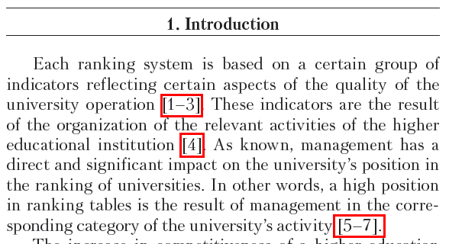

8. Formulas are issued only in the MathType formula editor. All characters within the same formula must be either Cyrillic or Latin. After the formula, the necessary sign is put (the end of the sentence is a point, the middle of the sentence or after the formula are explanations – a comma).
Check all through numbering of formulas.

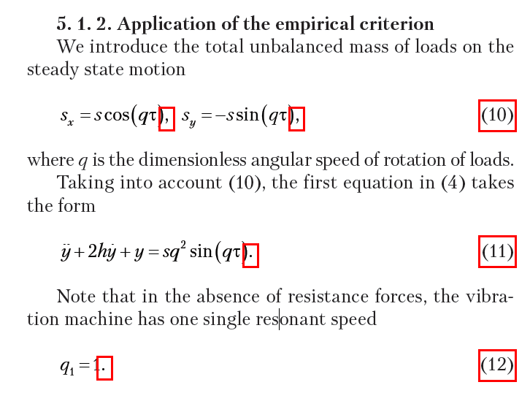

9. Signature of figures: Fig. 1. Name of figure.

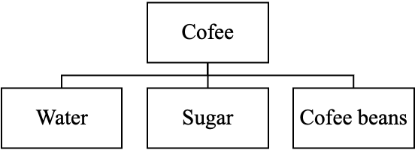

Fig. 1. Cup of coffee composition

10. If a graph is shown in the figure, then all signs, including the coordinate axes, should be decoded in the signature to the figure. The font (size and style) within the same graphic should be the same.

11. If the figure contains sub-figures (a, b, c), there should be an explanation for each sub-figure. The letters that stand for the sub-figures stand out in italics.

а b c

Fig. 2. Types of geometric figures: а – triangle; b – circle; c – square

12. The size of the signatures in the figures should correspond to the size of Times New Roman 14.
13. There should be no empty cells in the header of the table.


Тable 1
Sample characteristics
 | Taste | Color
1 | Sweet | Red
2 | Salty | White

Тable 1

Sample characteristics
Sample No. | Taste | Color
1 | Sweet | Red
2 | Salty | White

14. All tables are arranged vertically.
15. References are strictly in accordance with the standard.
16. References should contain at least 10 references, of which at least 60 % are to foreign publications.
17. The percentage of self-citation is not more than 30 % (that is, if you used 10 links, there can be no more than 3 of your works).
18. How to make links to our journal link.
19. References in English (not excluding references in the language of the article). References in English is drawn up according to an example.

20. Sources belonging to the Q1 and Q2 Scopus quartiles should be highlighted in purple. To check the log for belonging to a quartile, you can use this video.

20. Information on all co-authors should contain the name, position and title, place of work, country (name and full address), contact information (phone, e-mail), information on the availability of printed works, Hirsch index according to the Scopus database (if available), ORCID number is required!

Full name
Science degree
Department
University
Address University
E-mail:
ORCID:
Contact phone
Number of publications in national journals indexed (approximate; for Ukraine citizens only)
Number of publications in international journals indexed (approximate)
H-index by Scopus (if available)
ResearchGate:
ID Scopus:
Researcher ID:

